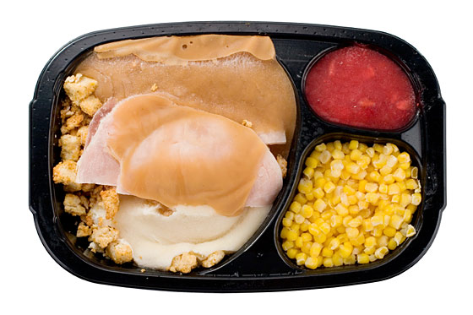  A Mighty Kids frozen meal includes 3.2 ounces of applesauce. If a child eats two frozen meals each week, how many ounces of applesauce will they consume in a year?  (Hint: There are 52 weeks in a year) | Multiply or Divide? Why? __________  _______________________________
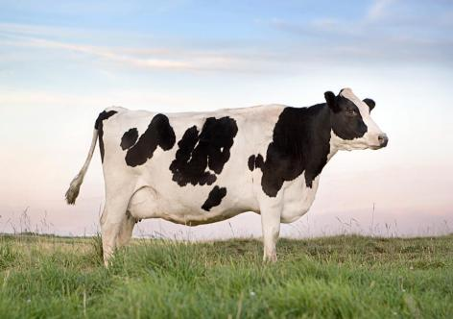  A dairy farm produces 624.3 liters of milk in 1.2 days. How many liters of milk a day are produced? | Multiply or Divide? Why? __________  _______________________________
Mrs. Wu’s car is completely out of gas. Gas costs $1.96 per gallon, and the car’s tank can hold 12.5 gallons. How much money will Mrs. Wu spend to fill her tank?   | Multiply or Divide? Why? __________  _______________________________
  Rick’s car has 4.5 gallons of gasoline. If he drives a total of 72 miles, then how many miles per a gallon does Rick’s car get? | Multiply or Divide? Why? __________  _______________________________
  Ellen jogs 2.45 miles each day. In the month of July she jogged 26 days. How far did Ellen jog in the month of July? | Multiply or Divide? Why? __________  _______________________________
Daniel ran 4.5 miles around a 0.75-mi track. How many laps did Daniel run?   | Multiply or Divide? Why? __________  _______________________________

